Report on Expiry Tracking System
1. Executive Summary
This project presents the design and implementation of an Expiry Tracking System using MariaDB 10.4. The system manages product categories, suppliers, batches, stock levels, and sales records, with a key focus on batch-level expiry monitoring. By enforcing foreign key constraints and relational integrity, the solution ensures accurate tracking of inventory and reduces waste from expired goods. The schema supports proactive alerts for expired or near-expiry items, making it a practical tool for businesses handling perishable or regulated products.
2. Business Case
- Problem Statement: Businesses often face losses due to expired stock, especially in industries like food, beverages, and pharmaceuticals. Manual tracking is error-prone and inefficient.
- Objective: Provide an automated, reliable system to monitor expiry dates, stock quantities, and sales, ensuring timely rotation and minimizing waste.
- Benefits:
  - Reduced financial losses from expired goods.
  - Improved supplier accountability and transparency.
  - Enhanced customer satisfaction by ensuring only valid products are sold.
  - Scalable solution adaptable to multiple categories and suppliers.
3. Design
Logical Design
- Entities & Relationships:
  - Categories → Products (1-to-many)
  - Suppliers → Products (1-to-many)
  - Products → Batches (1-to-many)
  - Batches → Stock (1-to-1)
  - Batches → Sales (1-to-many)
- Normalization: Achieved through six interconnected tables, avoiding redundancy and ensuring data integrity.
- Constraints: Primary keys (PK), foreign keys (FK), and referential integrity enforced via InnoDB.
Physical Design
- Database Engine: MariaDB 10.4 with InnoDB for ACID compliance.
- Charset: utf8mb4 for full Unicode support.
- Indexes: AUTO_INCREMENT primary keys for efficient record management.
- Sample Query Highlight:
sql
SELECT p.product_name, b.expiry_date, s.quantity_available
FROM products p
JOIN batches b ON p.product_id = b.product_id
JOIN stock s ON b.batch_id = s.batch_id
WHERE b.expiry_date < CURDATE()
AND s.quantity_available > 0;
→ This query generates an Expired Stock Alert.
4. Implementation
Screenshots (to be inserted)
- Database schema diagram.
- Sample SQL execution results.
- Expired stock alert query output.
Table Descriptions
- categories: Stores product categories.
- suppliers: Supplier details including contact info.
- products: Product metadata linked to category and supplier.
- batches: Batch-level details with manufacture and expiry dates.
- stock: Current stock levels per batch.
- sales: Records of sales transactions.
Sample Querries
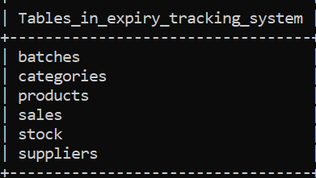

Querry 1
Sql SELECT*FROM batches
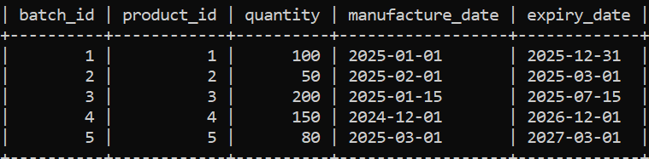

Querry 2
Sql SELECT*FROM categories
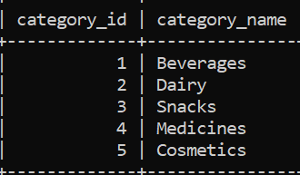
Querry 3
Sql SELECT*FROM products
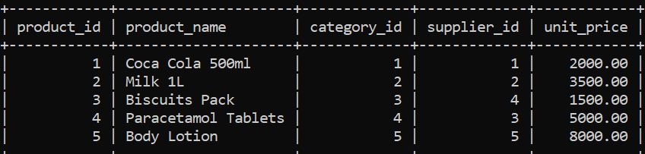

Querry 4
Sql SELECT*FROM sales
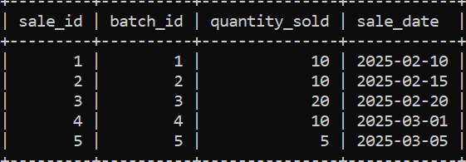

Querry 5
Sql SELECT*FROM stock
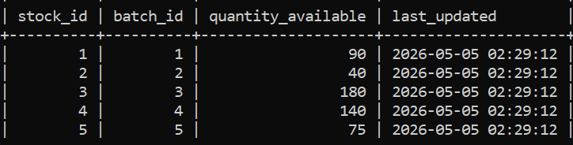

Querry 6
Sql SELECT*FROM suppliers

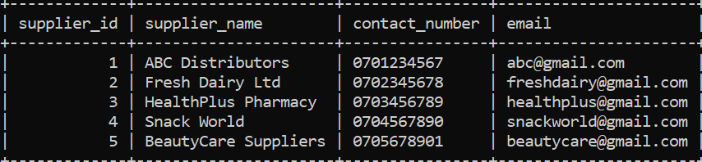

Expiry tracking
Expired batches;

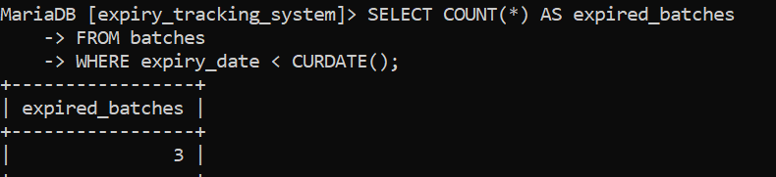

Expired products;
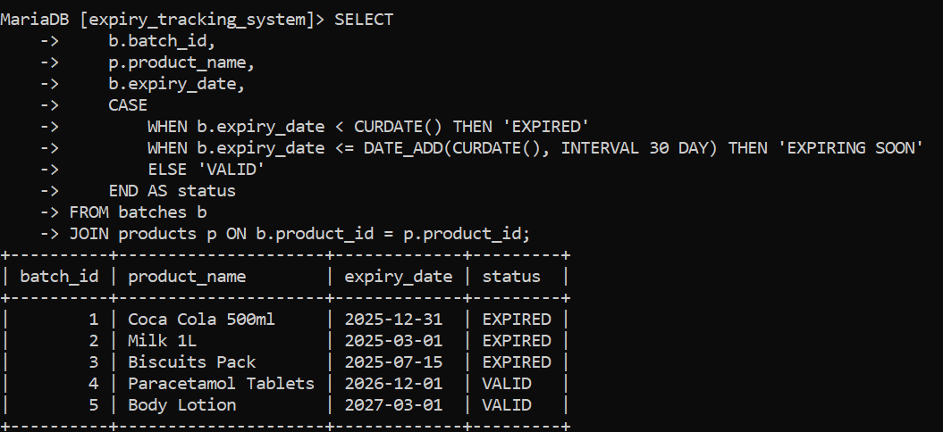

Valid products

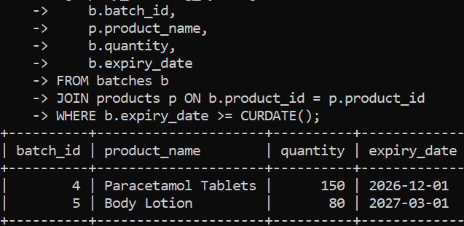

Physical Schema

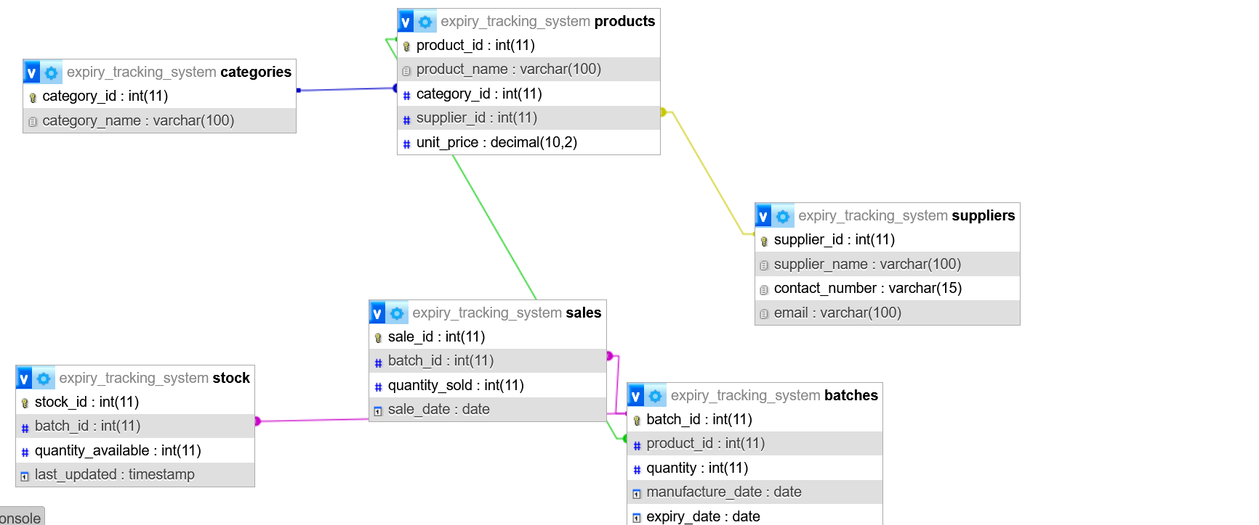

- Total Units in Stock: 525
- Units Sold: 55
- Expired Products: Milk (40 units), Biscuits (180 units).
- Active Products: Coca Cola, Paracetamol, Body Lotion.
Query Results
- Expired stock alert correctly flagged Milk and Biscuits as expired.
- Active stock items remain available for sale

5. Bibliography
- MariaDB Documentation: https://mariadb.com/docs/
- Elmasri & Navathe, Fundamentals of Database Systems, 7th Edition.
- Connolly & Begg, Database Systems: A Practical Approach to Design, Implementation, and Management.
- Academic references on inventory management and expiry tracking systems.
✅ With this structure, you can easily expand each section into full pages:
- Executive Summary: ~1 page

